**ZakData Flow Diagram**

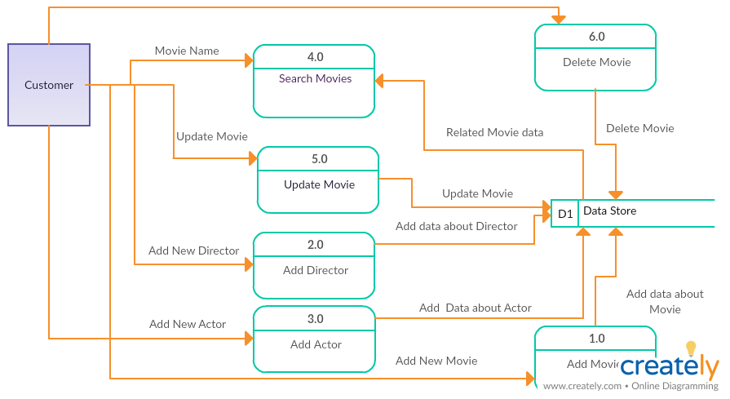**fig1: DFD**

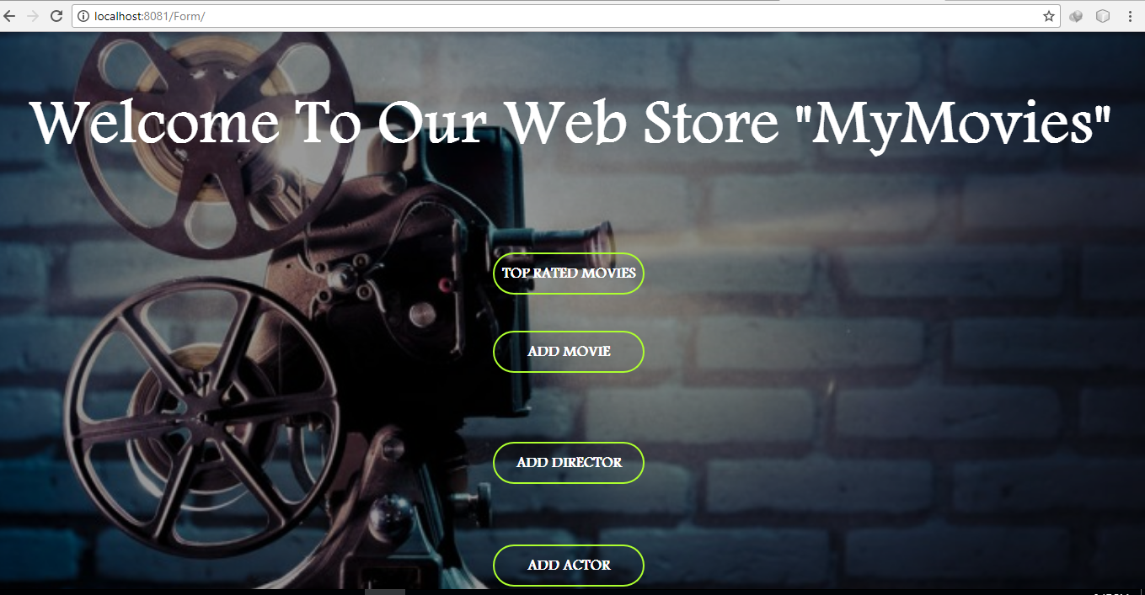**Fig2: HomePage**

**Fig3:Search Movies**

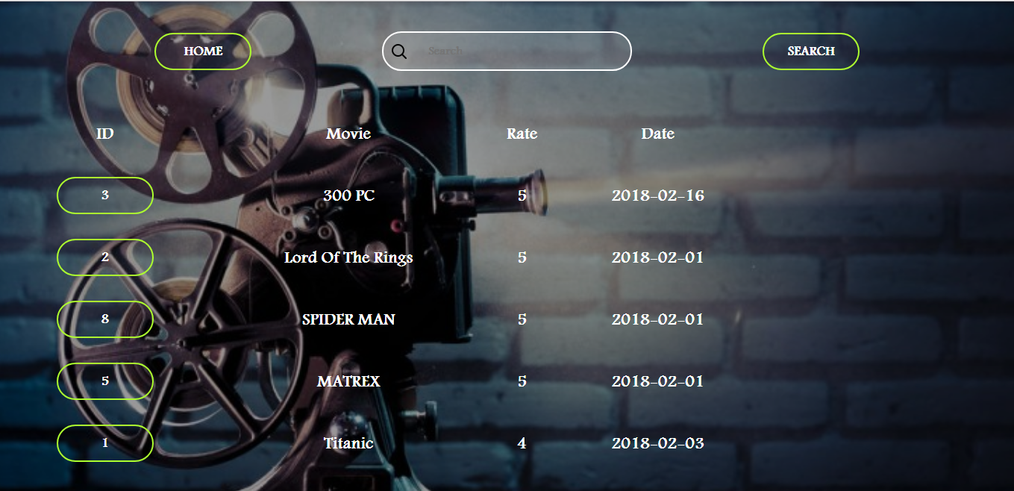

**Fig4:Update&Delete Movie**

